**FLASH SALE FEATURE ON HAPPYDAY SHOP by KATALON**

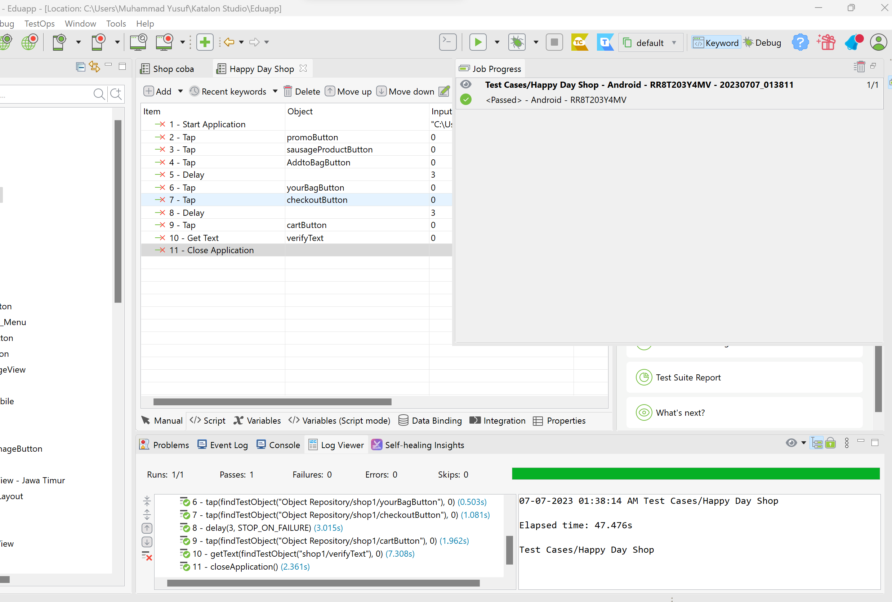

**Succesfully.**